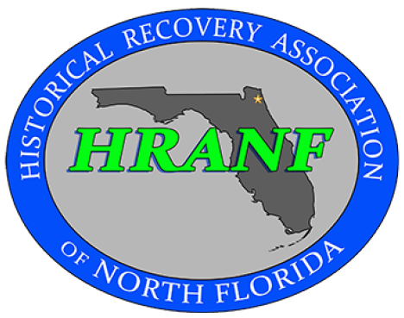 | Membership Form | Date: ________________  Amount Paid: ________  Single or Family Membership
Name _____________________________________________________
Address ___________________________________________________
Phone Number _____________________________________________
Do you want your phone number shared with other members? Yes or No
Email Address ____________________________________________
If you are on Facebook, would you like to be part of our Private Group? Yes or No
Family Membership List family members and if they have different Email address
Family Member ____________________________ Email ____________________________________
Family Member ____________________________ Email ____________________________________
Emergency Contact Information
Name______________________________ Relationship _____________________ Phone:______________________________
Ethics for Responsible Metal Detecting:
I will check Federal, State, County and Local Laws before searching. It is my responsibility to know and understand the law.
I will never remove or destroy significant historical archeological treasures.
I will not enter cemeteries for the purpose of metal detecting.
I will not enter private property without the owner's permission and, when possible, such permission will be in writing.
I will refill all holes and try not to leave any damage.
I will remove and dispose of any and all trash and litter that I uncover.
I will not destroy or tamper with any structures on public or private properties.
I will not tamper with signs, maintenance facilities or equipment and leave all gates as found.
I will educate those who do not follow good metal detecting practices and be welcoming to others who are interested in the hobby.
I will make every effort to return found property to its rightful owner.
I will be an ambassador for the hobby, be thoughtful, considerate and courteous at all times to others and their property.
I agree to release and discharge any and all liability claims resulting in any personal injury incurred at any club meeting, event or permission during my active membership. This liability release applies to our Club President, Vice President, Treasurer, Secretary, and advisors’. This release of liability also applies to Holiday Hill Baptist Church, its Pastor, staff, Directors, and all officers.
__________________________________ __________________
Signature Date

